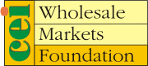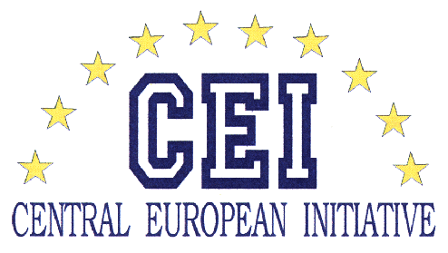

Central European Initiative Wholesale Markets Foundation
Warsaw Wholesale Market Bronisze
I FORUM OF TRADERS AND PRODUCERS
FROM WHOLESALE MARKETS
OF CENTRAL AND EASTERN EUROPE

28 May 2012 – Bronisze, Poland

Ladies and Gentlemen, dear friends,

On behalf of the Management Board and all the members of our growing CEI Wholesale Markets Foundation I have a special privilege and pleasure to welcome you and to address this meeting with a few words.

Let me first briefly remind you a short history of our Foundation. The first idea about such an organization came on in 1998, during a pleasant meeting with beers held in a charming restaurant on the central square of Warszawa, Stare Miasto, where a couple of people were discussing how to help each other to implement, promote and improve wholesale market’s model of trading in their countries. Very soon after this meeting the idea became through.

With the assistance and multiple supports from our main sponsors, the European Bank for Reconstruction and Development (EBRD), the Central European Initiative (CEI), Food and Agriculture Organization of the United Nations (FAO) and the United Nations Economic Commission for Europe (UNECE) three founding members, WM Bronisze, WM Budapest and National WM Company Croatia have established the Wholesale Markets Foundation under the high sponsorship of the Central European Initiative. I’d like to use this opportunity to honestly thank all of them for their huge support, including a support for this event from the Central European Initiative granted to co-finance the costs of participation of the non-EU Foundation members in this meeting.
In the meantime our Foundation was growing, slowly but safely, so from the initial three WM from three countries today we have organization of 18 WM from eight countries with prospects of further growth. Having on mind how many global and regional associations of wholesale markets exist today I could say that we may be proud of our success.
I'd like to use this opportunity to cordially greet all of our Foundation members from Albania, Bosnia and Herzegovina, Croatia, Poland, Romania and Ukraine. I’d also like today to warmly welcome Mr. Dario Kobešćak and his assistant Mrs. Lucija Tomić-Černi from WM Zagreb, our latest Foundation member, and to encourage other potentially interested countries such as Italy, Russian Federation, Belarus, Moldova, Macedonia and others to join us.
I have been asked by Mr. Tibor Kekedi from WM Budapest, Mr. Zoran Kovač from WM Osijek and Mr. Dragan Pušara from WM Belgrade, our next new member, to pass their kind regards to the participants of the meeting and to excuse them for absence because of some high priorities in their companies or countries.
As you all know, the primary objective of our Foundation is to help the newly established wholesale market companies in Central and Eastern Europe to develop and improve their operations to better serve their clients and increase their revenue earning capabilities.
We really do serve our clients, particularly wholesalers, producers and their organizations and that was the reason why the Foundation, for the first time in its history, has organized this regional Forum – a joint seminar of the WMs representatives from the CEE countries together with representatives of traders and producers from these markets. Simply speaking, our intention was to organize this BtoB meeting in order to help all involved players to overcome the present difficult period caused by the global economic crisis, to introduce each other, to exchange contacts and to start business for better future for all of us. I really do hope that you will all use this opportunity in the best possible manner.
At last but certainly not least, I'd like to thank Mr. Miroslaw Mazuruk, the President of Bronisze WM, and the team of people from the Bronisze WM and the Foundation in the complex organization of this event, particularly Mr. Krzysztof Karpa, Mrs. Elzbieta Walczynska and others for the great job done in preparation of this workshop. Without their support and personal engagement such an ambitious event wouldn’t be possible.
Ladies and gentleman thank you all once again for coming. I wish you a pleasant stay in Poland and successful work.

Zoran Krsnik
President of the Management Board

Warszawa, 28 May 2012

